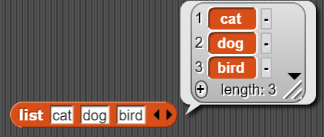Lists

**Delete Items**

**Delete Items**

**Add Items**

**List Items**

**List block located in “Variables” Menu**

**Index Number**

**Length**